
KCXDocumentor - Sample Generated User Guide - Blink Rx
Example generated guide packaged for executive review
Recipe alignment
Built as a keycentrix internal artifact using the DamienDev document recipe structure: control metadata, version history, purpose, scope, audience, governance, process detail, and appendices.

Metadata Field | Document Value
Document ID | KCXDOC-SAMPLE-001
Version | 1.0
Effective Date | 2026-06-05
Status | Internal showcase sample
Owner | keycentrix Product and Training
Audience | Executive Team, Product, Training, Implementation, and Documentation Reviewers
Build Standard | DamienDev document recipe

Package Notes
- The following pages are the generated guide output used to demonstrate KCXDocumentor capability.
- This front matter was added for the executive collateral package.
- The generated guide content remains available for review behind this package section.


Blink RX Integration: Workflow Guide for New Leaf Users
DRAFT — Pending Human Review
keycentrix - Prototype
This guide explains how the Blink RX interface works with New Leaf and walks you through the key request types you will encounter: transfer in, claim, dispense, and transfer back. It also covers how to use the Blink Mock Tool to generate and manage test orders during setup and validation.

Document Control Metadata
Metadata Field | Document Value
Owner | KCXDocumentor
Effective Date | 2026-06-04
Status | Prototype
Version | DRAFT — Pending Human Review

Purpose
This guide explains how the Blink RX interface works with New Leaf and walks you through the key request types you will encounter: transfer in, claim, dispense, and transfer back. It also covers how to use the Blink Mock Tool to generate and manage test orders during setup and validation.

Intended Audience
- Application users

Prerequisites
- Access to New Leaf with pharmacy profile configuration permissions.
- Blink RX enabled for your pharmacy via the setup SQL script (see Blink technical documentation on Confluence).
- Blink Mock Tool installed in your environment (see Blink Mock Tool Installation documentation).
- A Blink customer type created in the pharmacy profile.
- An AR (accounts receivable) account assigned for Blink in the pharmacy profile.
- A plan template selected in the Blink pharmacy profile settings.
- At least one customer profile configured with the Blink customer type and the required insurance plans.

Workflow Overview
- Follow the workflow sections in order and confirm the expected screen or request status before moving to the next step.

Step-by-Step Procedures

Blink RX Overview and How It Works with New Leaf

1. Understand the Blink RX workflow
Action: Blink RX is an interface integrated with New Leaf. Blink receives prescriptions from patients and sends them to New Leaf. New Leaf then handles claim adjudication, dispensing, and the rest of the pharmacy workflow. Blink communicates with New Leaf through an API that polls at a configured interval (for example, every 10 seconds).
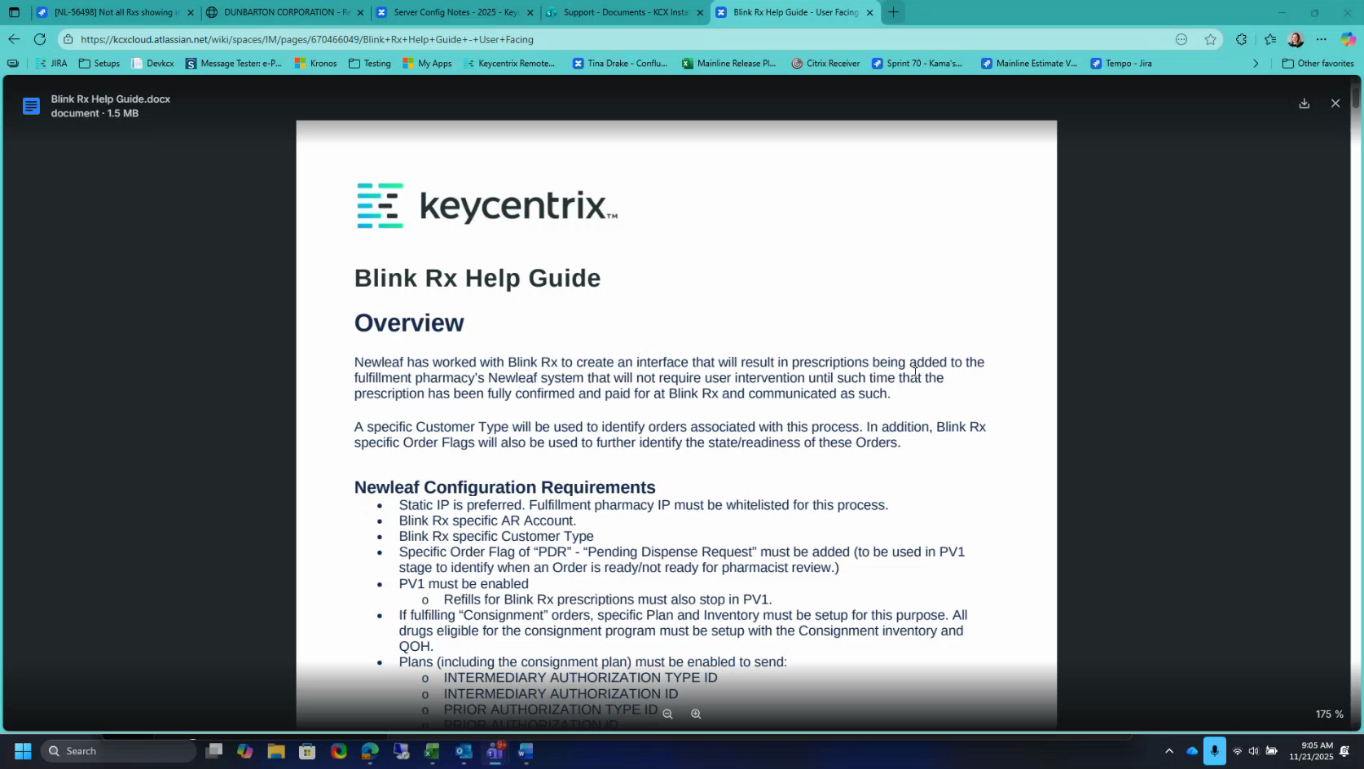
Candidate screenshot at 00:01:30.000

2. Identify the Blink request types
Action: The Blink integration uses five request types that you will work with in New Leaf:
- Transfer In — Brings a prescription order into New Leaf Data Entry.
- Claim — Triggers adjudication for the order.
- Dispense — Signals that the claim is complete and the order is ready to process.
- Transfer Back — Returns an order to Blink (can occur at three stages; see the Transfer Back section).
- Refill — Initiates a refill request.
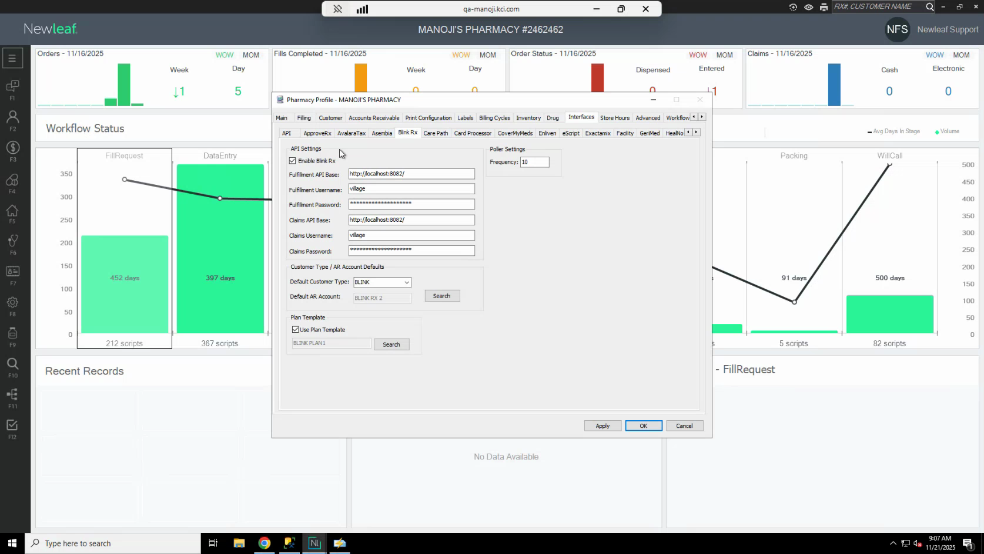
Candidate screenshot at 00:03:30.000

Configure the Blink RX Pharmacy Profile

3. Open the pharmacy profile interfaces screen
Action: In New Leaf, open the pharmacy profile using the keyboard shortcut F8F6, then navigate to the Interfaces tab. Locate the Blink RX section.
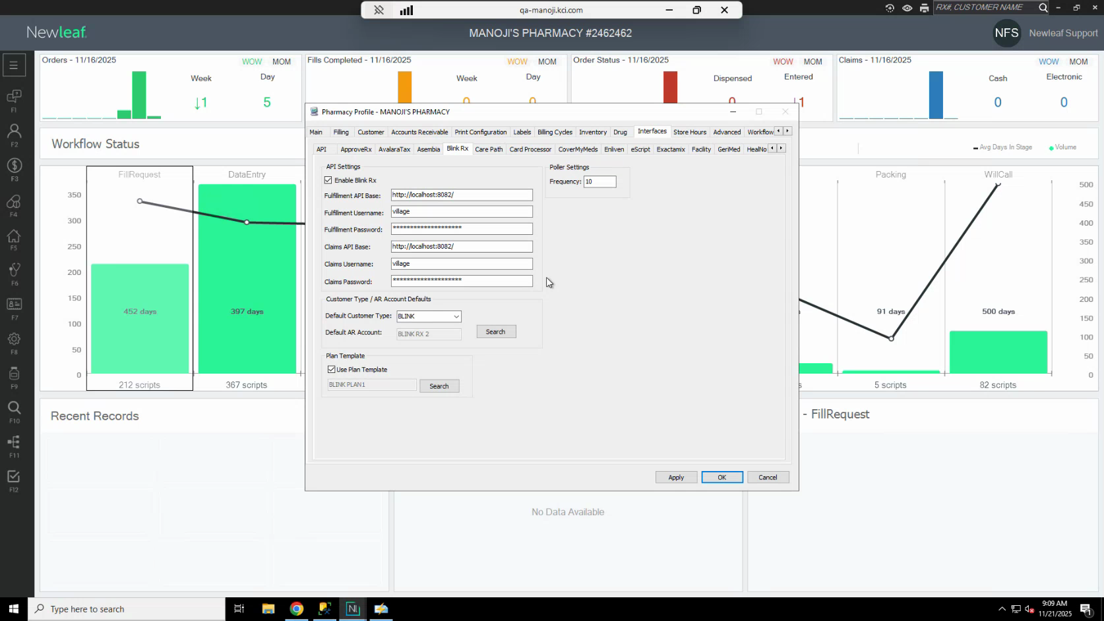
Candidate screenshot at 00:05:00.000

4. Enable Blink RX using the setup script
Action: Enabling Blink RX requires running a SQL script. Locate the script in the Blink technical documentation on Confluence by searching for Blink.
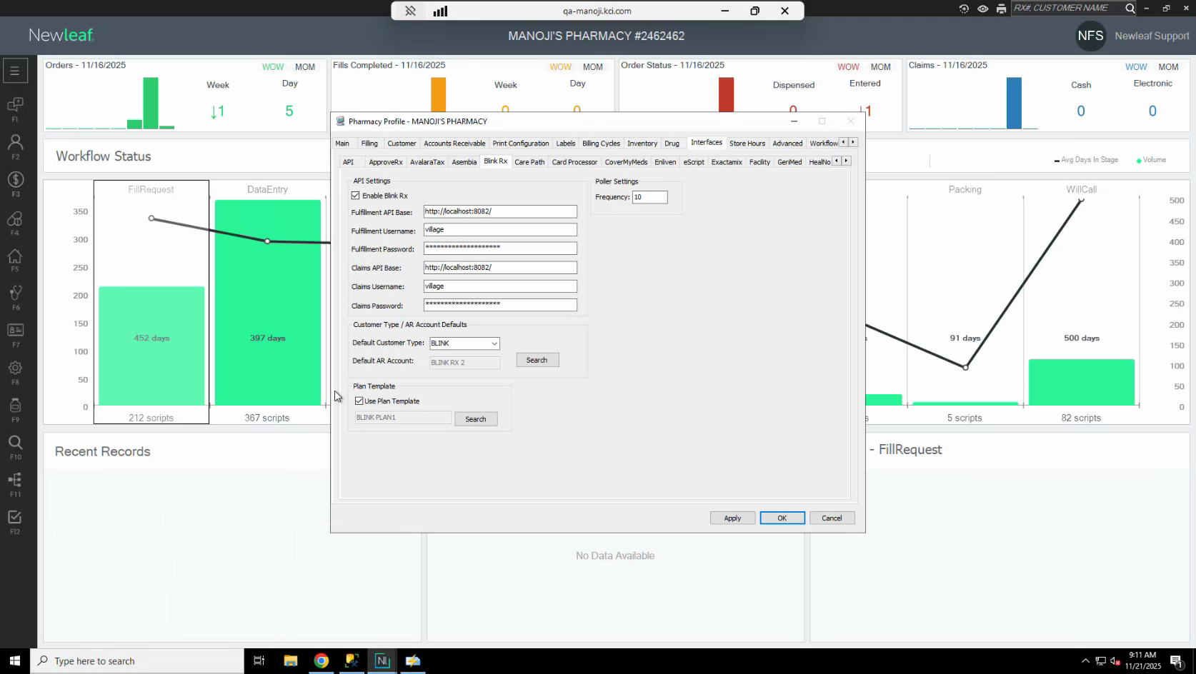
Candidate screenshot at 00:07:00.000

5. Configure the API polling interval and credentials
Action: In the Blink RX section of the pharmacy profile, set the polling frequency (the interval at which New Leaf checks for new Blink requests). A value between 10 and 30 seconds is typical; 10 seconds is recommended for active testing. Enter the API base URL and the Blink account credentials in the designated fields.
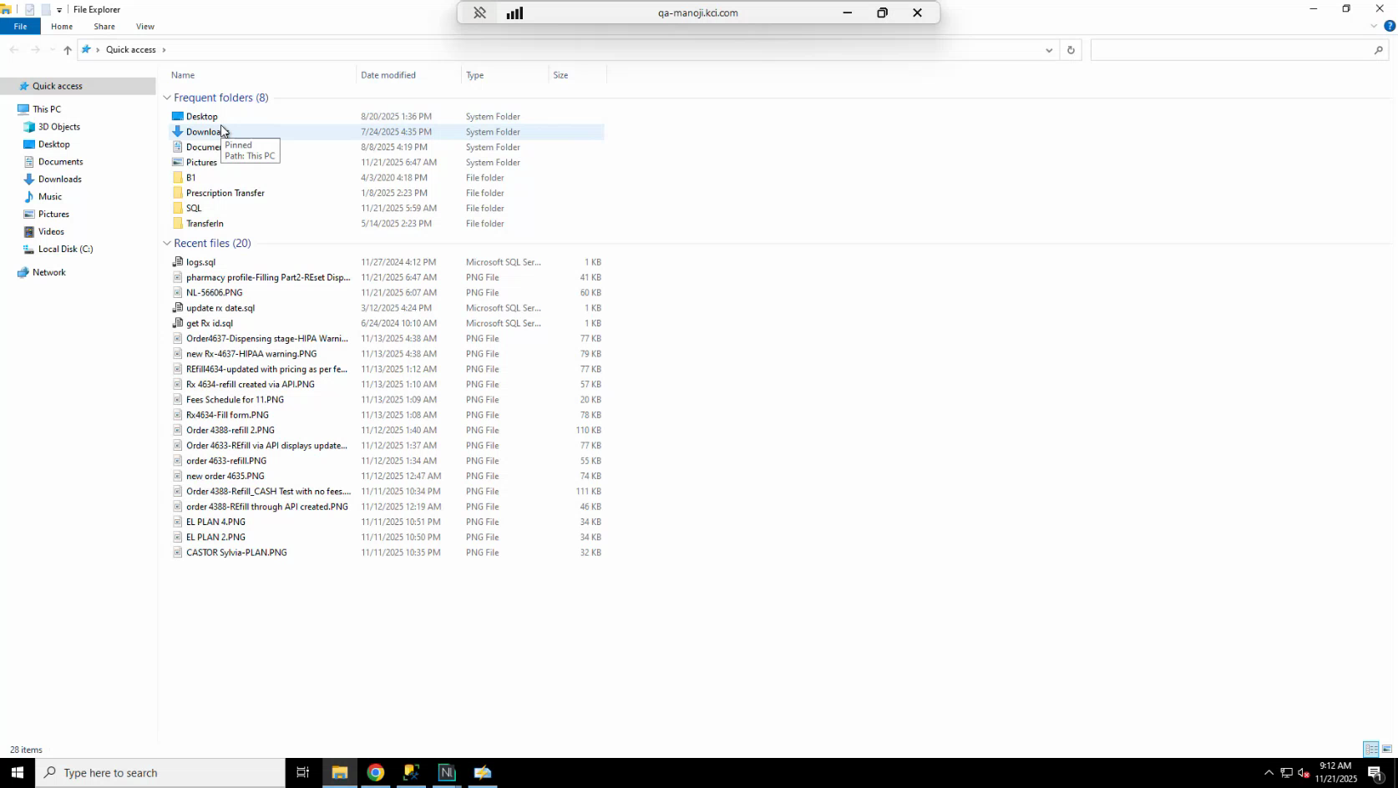
Candidate screenshot at 00:08:30.000

6. Assign the Blink customer type and AR account
Action: In the Blink settings, set the Customer Type field to the Blink-specific customer type (for example, Blink). Use the AR account search to select the correct AR account for Blink. You can create or manage customer types from the Customer tab in the pharmacy profile.
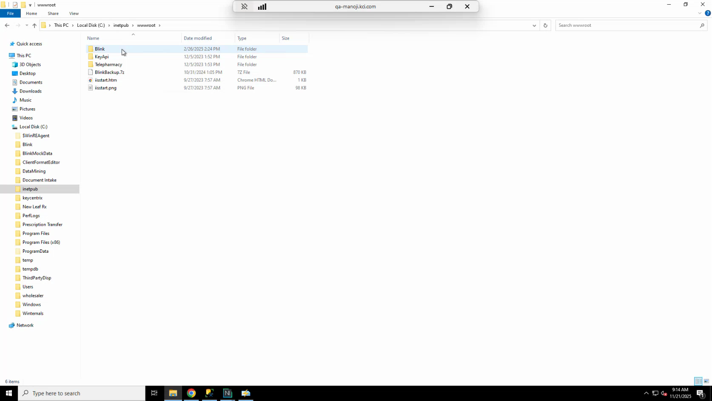
Candidate screenshot at 00:10:00.000

7. Select a plan template
Action: In the Blink settings, select the plan template to use as the base plan type for Blink orders. This plan will be applied when Blink orders are processed through New Leaf.
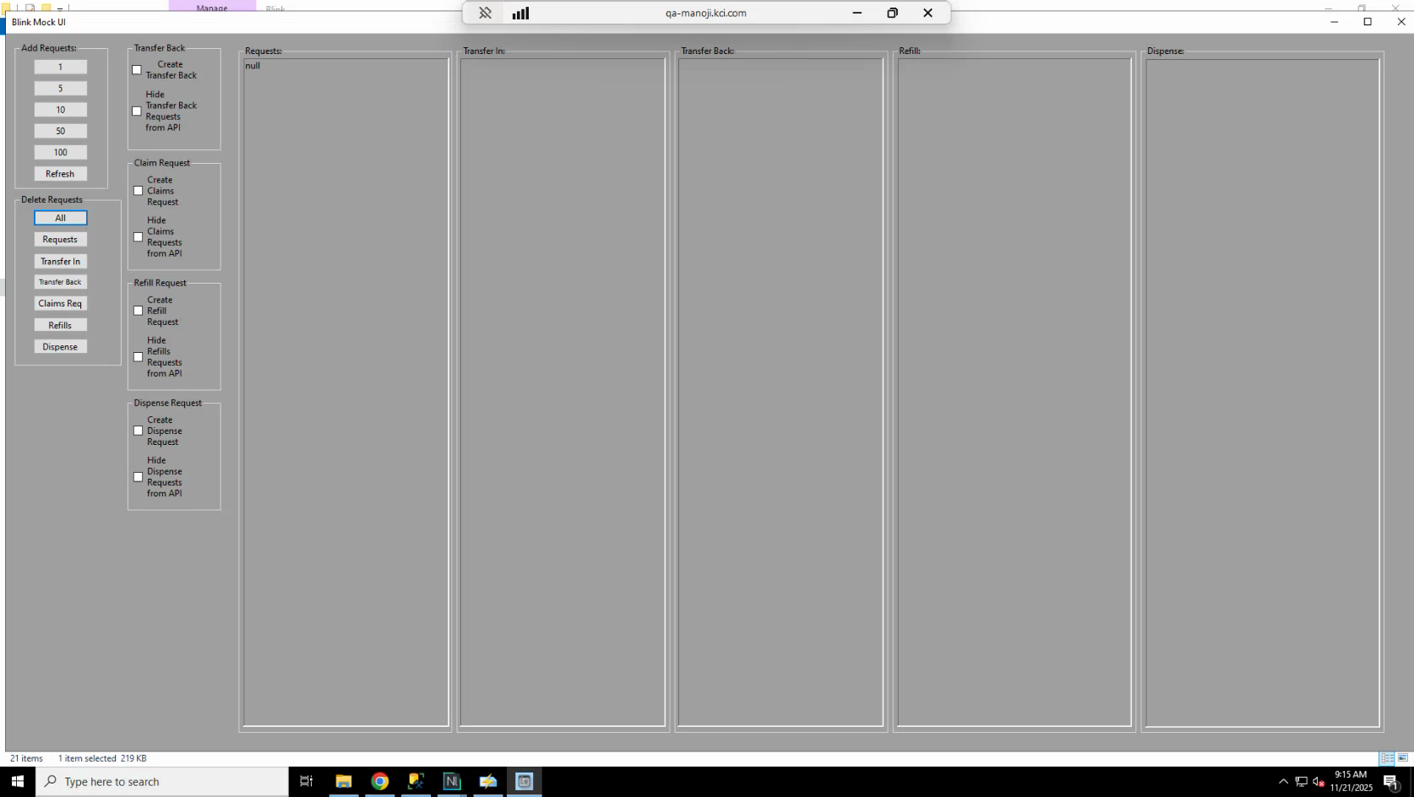
Candidate screenshot at 00:11:30.000

Set Up and Use the Blink Mock Tool

8. Locate the Mock Tool files
Action: The Blink Mock Tool is installed on the C: drive. It contains two folders: one for the UI and one for the API. For day-to-day testing, you only need the UI folder.
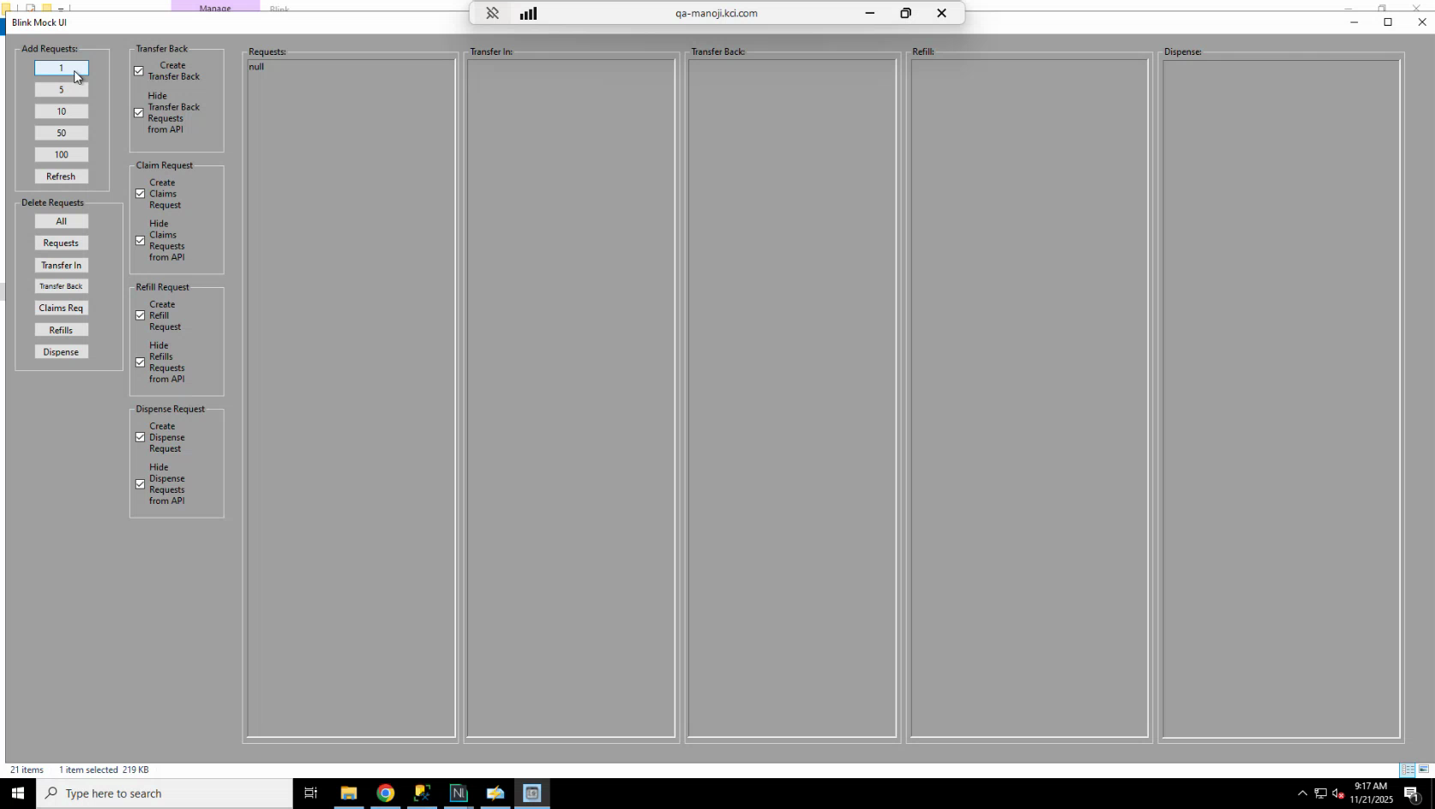
Candidate screenshot at 00:13:30.000

9. Open the Mock Tool UI
Action: In the Blink UI folder on the C: drive, open BlinkMockUI.exe. When the application opens, you will see a blank window with tabs or buttons for the available request types: Transfer Back, Claim Request, Bill Request, and Dispense Request.
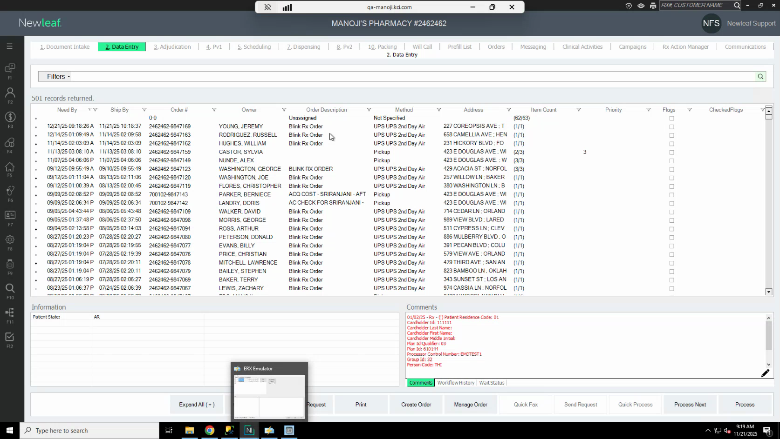
Candidate screenshot at 00:15:00.000

10. Select request types before sending a transfer in request
Action: Before sending a Transfer In request, select all the required checkboxes in the Mock Tool. This ensures that the associated requests (Transfer Back, Claim, Refill, Dispense) are generated together with the Transfer In order. You can deselect individual request types if you want to generate only specific requests.
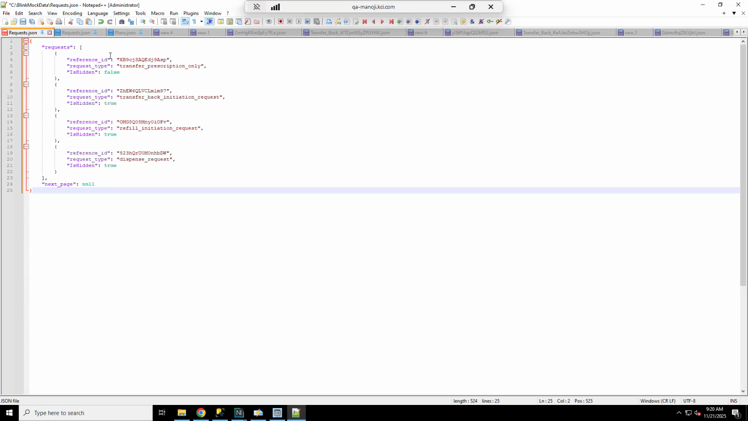
Candidate screenshot at 00:16:30.000

11. Set the number of requests to generate
Action: Use the quantity field in the Mock Tool to specify how many orders to generate. For example, entering 1 sends a single order to Data Entry; entering 5 sends five orders.
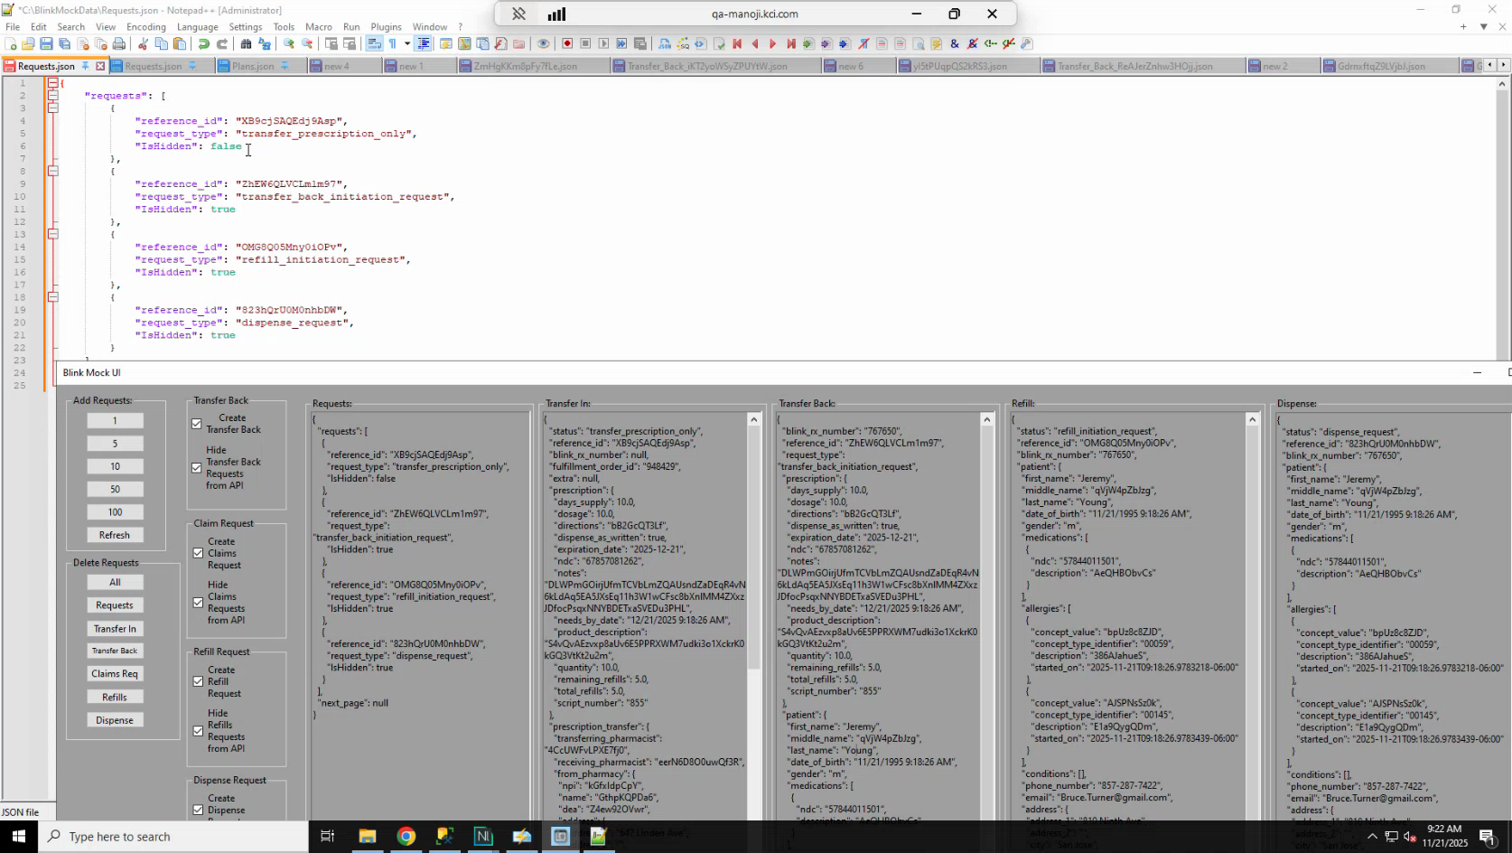
Candidate screenshot at 00:18:00.000

12. Inspect and edit the request JSON files
Action: The Mock Tool stores request data as JSON files in the Blink Mock Data folder on the C: drive. To view or edit a request file, open it in Notepad++ and use the JSON Viewer plugin (available from the Notepad++ Plugins menu) to format the file for easier reading.
The folder structure is:
- Blink Mock Data\requests.json — Transfer In and related requests.
- Blink Mock Data\data\claims\requests.json — Claim requests only.
- Blink Mock Data\data\custom data\plans.json — Plan details used by transfer and claim requests.
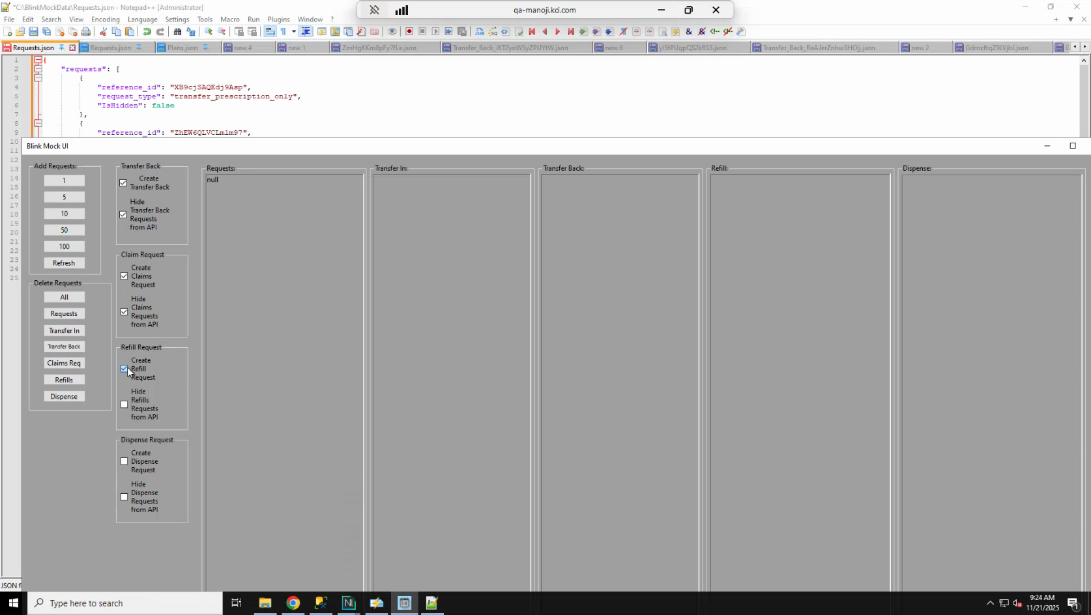
Candidate screenshot at 00:20:00.000

13. Control which requests are active using the isHidden field
Action: Each request entry in the JSON file has an isHidden field that controls whether the polling processor runs that request.
- isHidden: false — The request is active and will be sent on the next poll cycle.
- isHidden: true — The request is paused and will not be sent.
To activate a request, set isHidden to false and save the file. To stop a request after it has run, set isHidden back to true and save the file immediately. If you do not stop the request promptly, it will continue to run on every poll cycle.
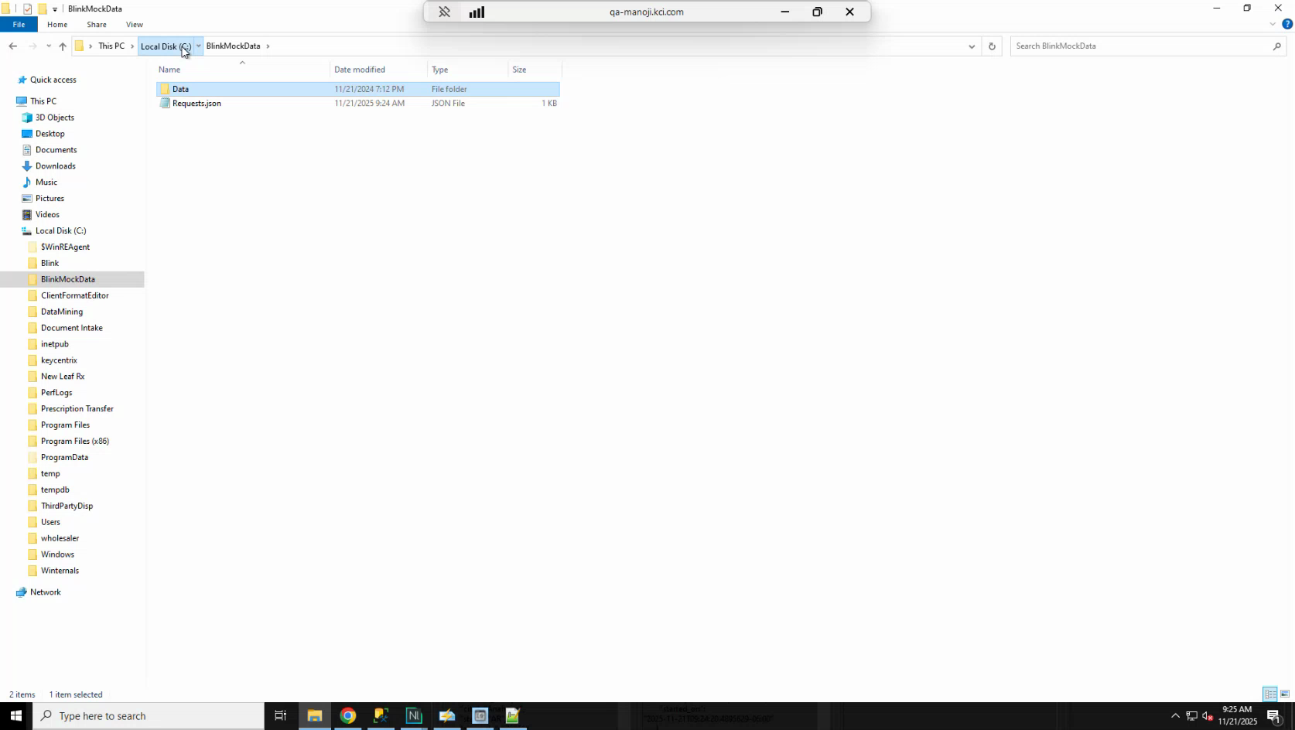
Candidate screenshot at 00:21:30.000

14. Delete test requests
Action: Use the Delete Request section in the Mock Tool to remove all requests or specific individual requests from the queue.
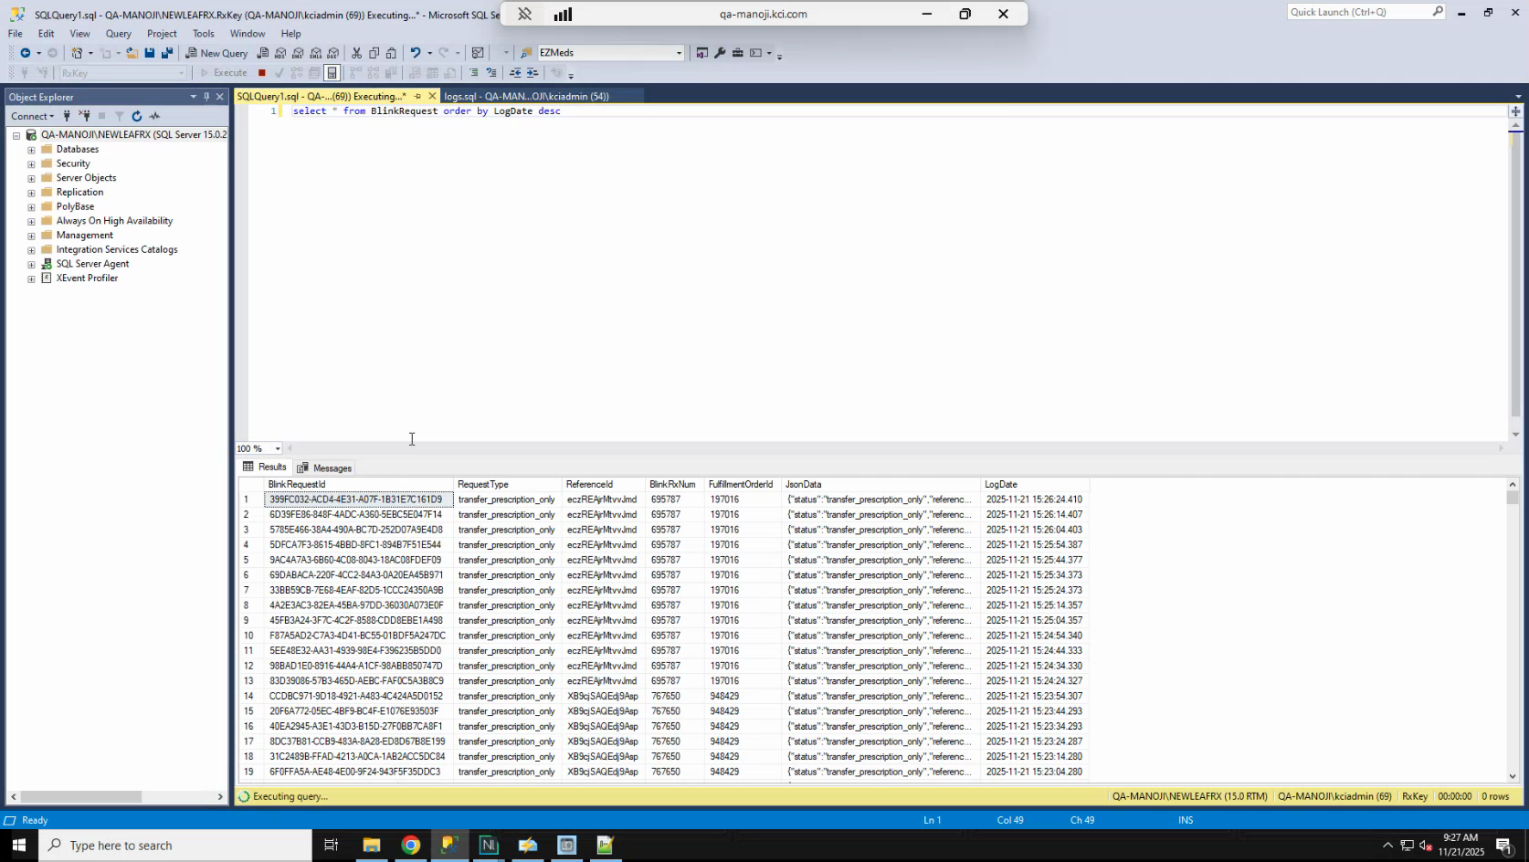
Candidate screenshot at 00:23:00.000

Send a Transfer In Request and Locate the Order in New Leaf

15. Activate the Transfer In request
Action: In the requests.json file, locate the Transfer In entry (request type: Transfer Prescription Only). Set isHidden to false and save the file. The polling processor will pick up the request within the configured polling interval.
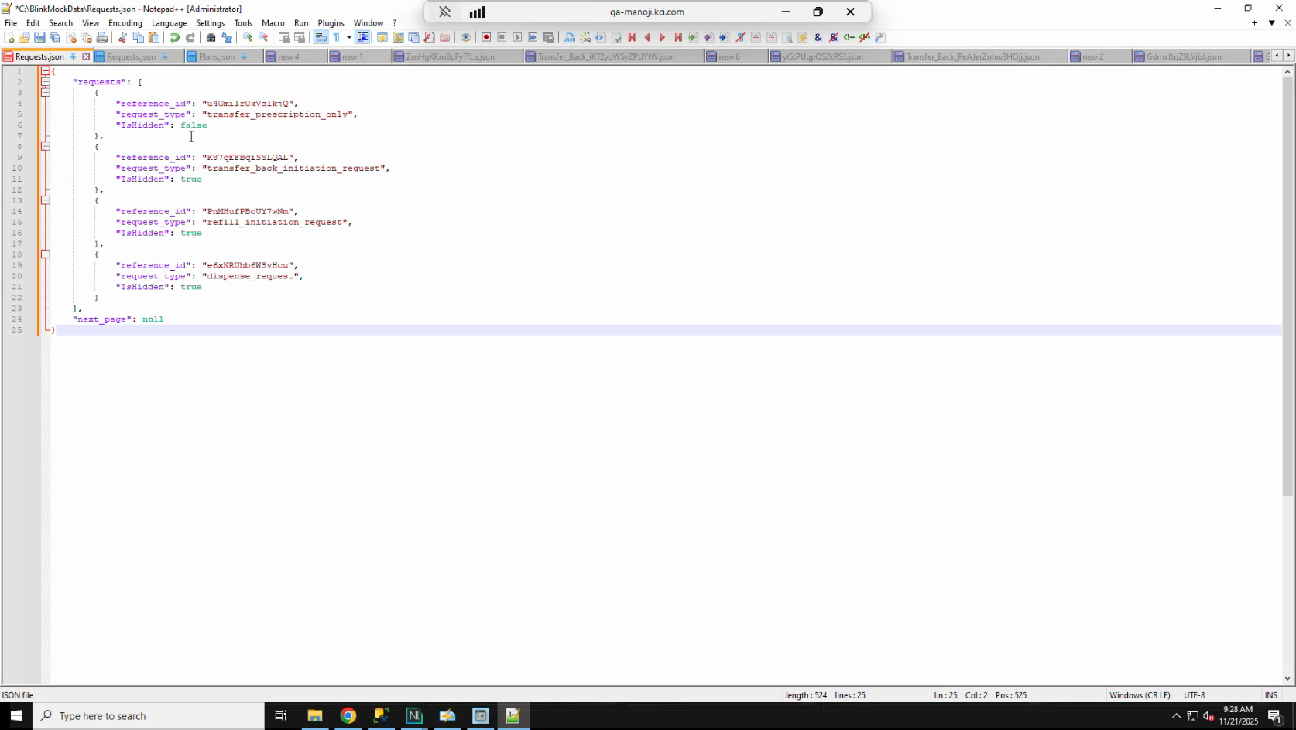
Candidate screenshot at 00:24:30.000

16. Verify the polling processor is running in System Logs
Action: In New Leaf, open System Logs and sort by log date descending. Look for log entries with the source Blink Fulfillment Processor. These entries confirm that the polling is active and running at the configured interval.
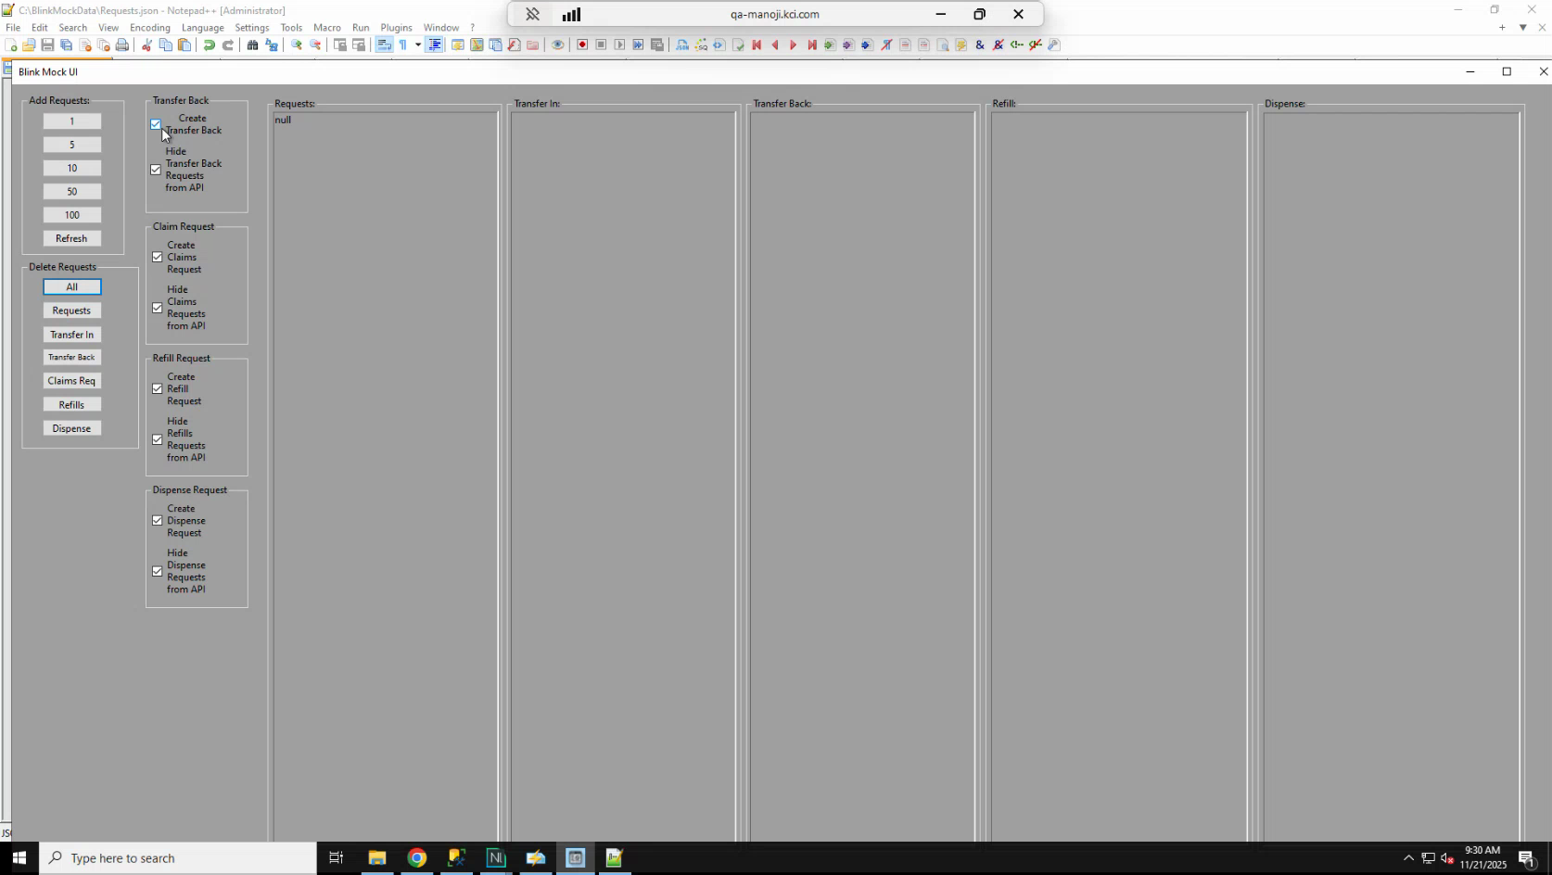
Candidate screenshot at 00:26:30.000

17. Locate the incoming order in Data Entry
Action: In New Leaf, open Data Entry using the keyboard shortcut F11. Refresh the list and sort by Need By date to find the new order. The patient name in the transfer request (for example, the name visible in the Transfer Back section of the Mock Tool) can help you identify the correct order.
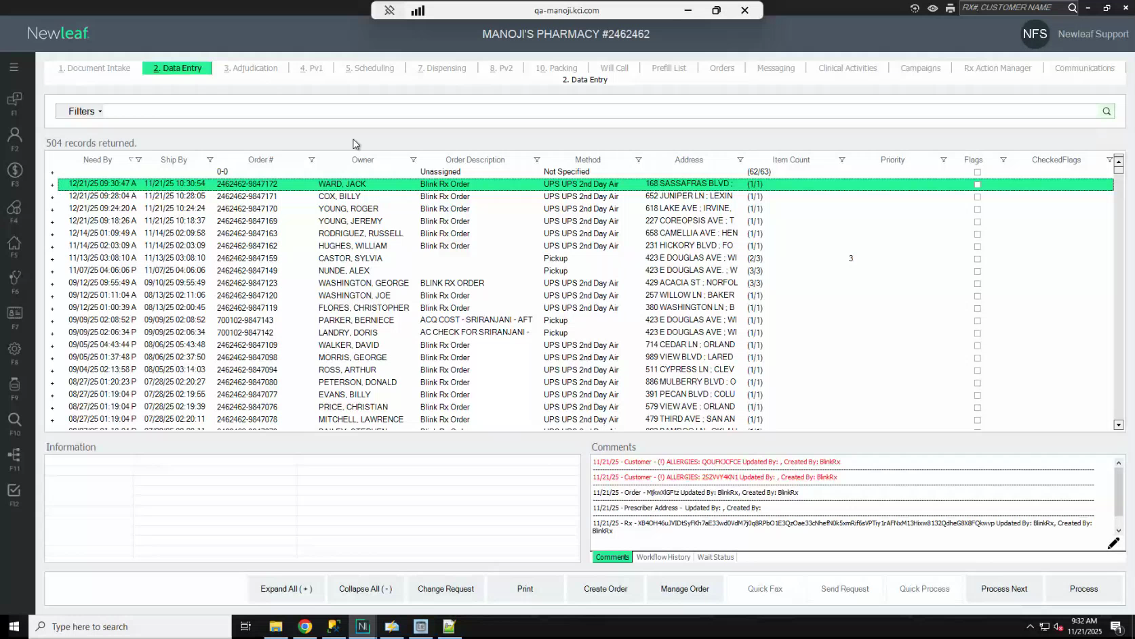
Candidate screenshot at 00:28:00.000

18. Stop the Transfer In request after the order appears
Action: As soon as you see the order in Data Entry, return to the requests.json file, set the Transfer In entry's isHidden field back to true, and save the file. Verify in System Logs that the Blink Fulfillment Processor entries for that request have stopped.
Important: You must stop the Transfer In request before running any other request type (Claim, Dispense, or Transfer Back). Running two transfer requests simultaneously will prevent other request types from processing.
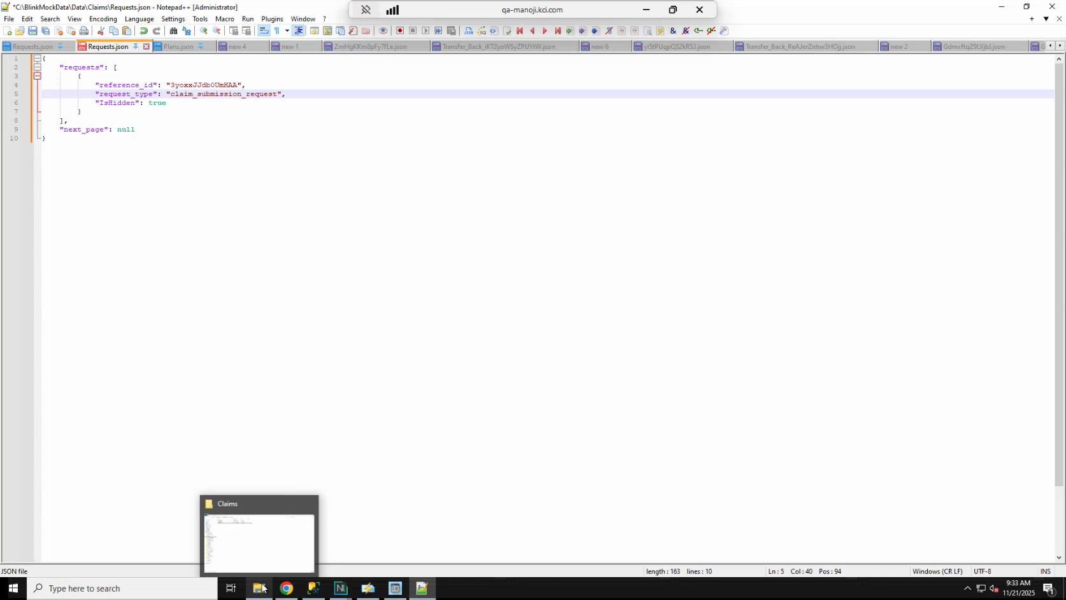
Candidate screenshot at 00:29:30.000

Run the Claim Request

19. Understand what the claim request does
Action: After the Transfer In order arrives in Data Entry, Blink sends a Claim request. This triggers automatic adjudication in New Leaf. The claim is processed against the insurance plans on the customer's profile. Three plan tiers are used: primary, secondary, and tertiary.
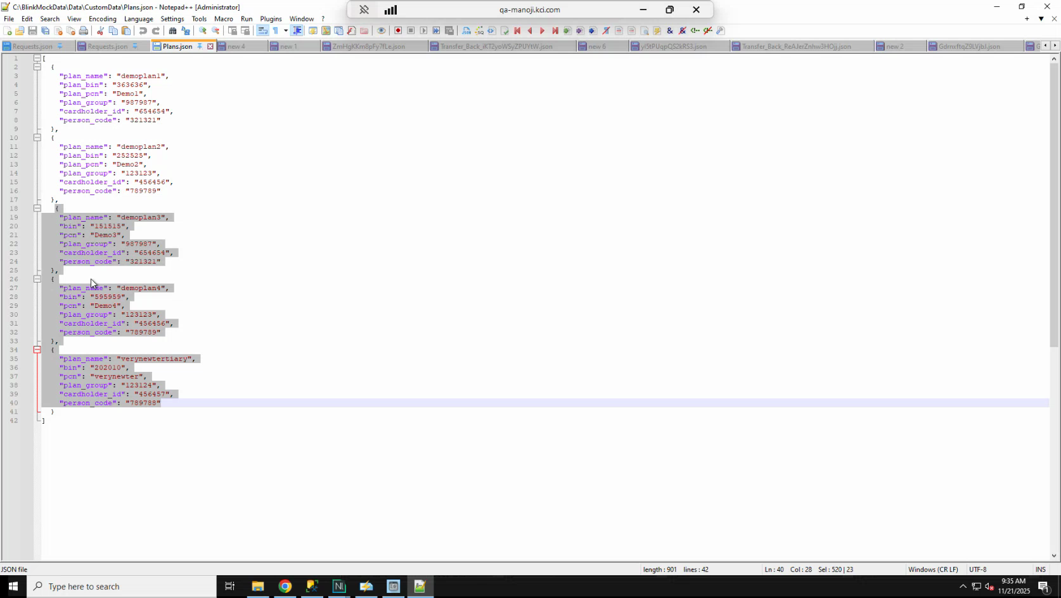
Candidate screenshot at 00:31:00.000

20. Verify the customer profile has the required plans
Action: Before running the claim, confirm that the customer's profile includes the insurance plans that will be used for adjudication. Open the customer profile and check the Plans tab. The plans listed there (for example, Demo Plan 1 and Demo Plan 2 for the transfer request, and the primary, secondary, and tertiary plans for the claim) must match the plan details in the plans.json file in the Mock Tool's custom data folder.
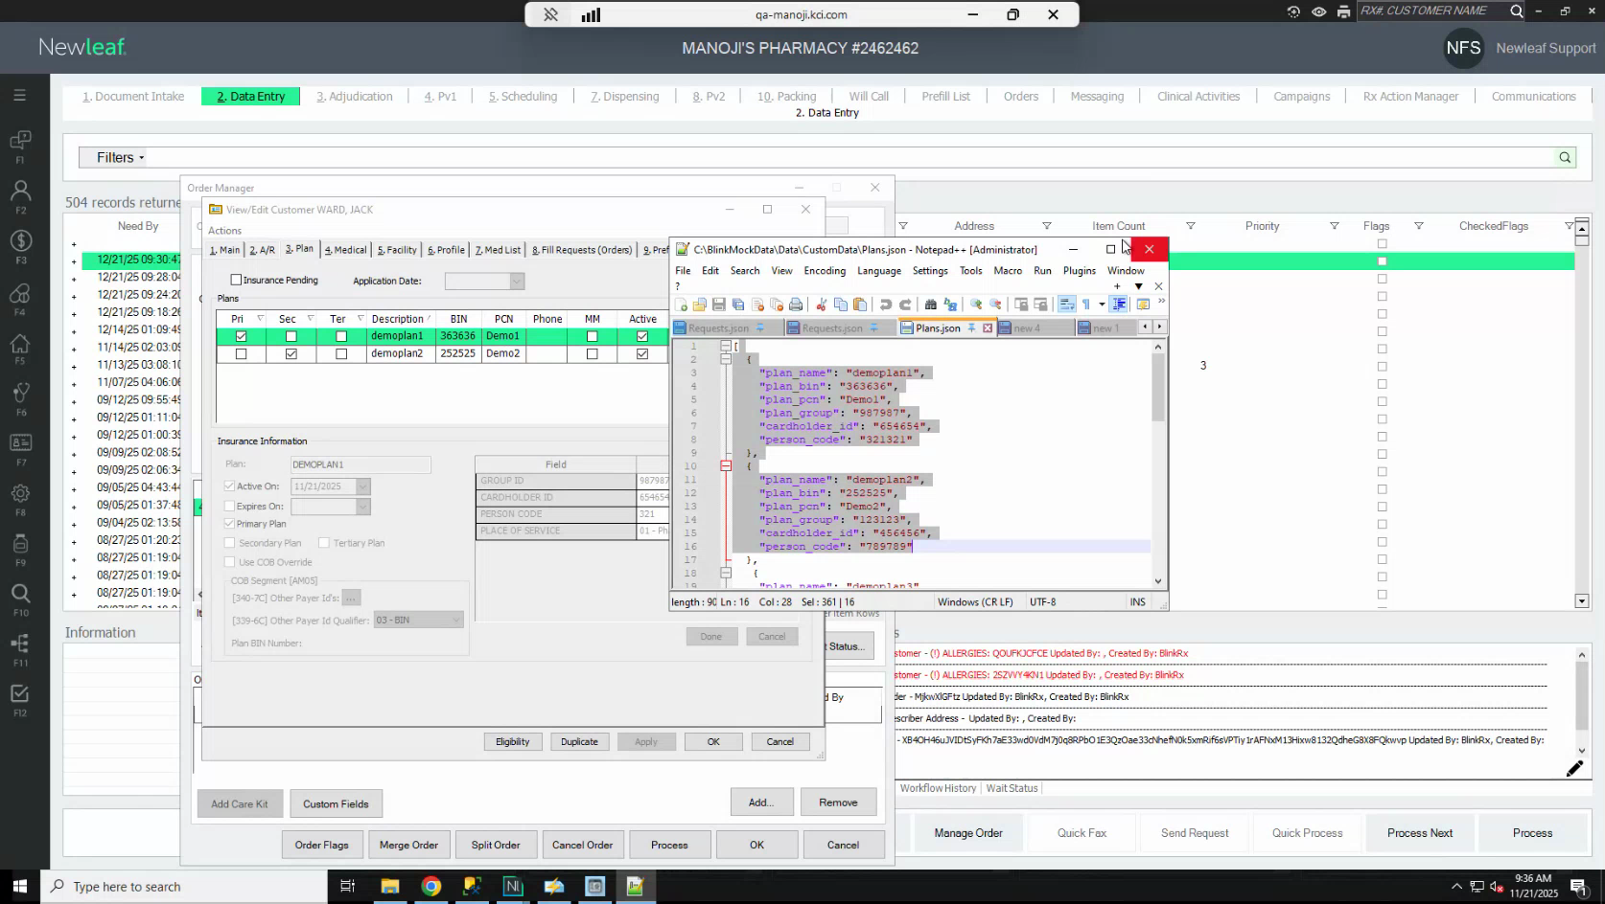
Candidate screenshot at 00:32:30.000

21. Activate the claim request
Action: Open the Blink Mock Data\data\claims\requests.json file. Locate the claim submission entry and set isHidden to false. Save the file.
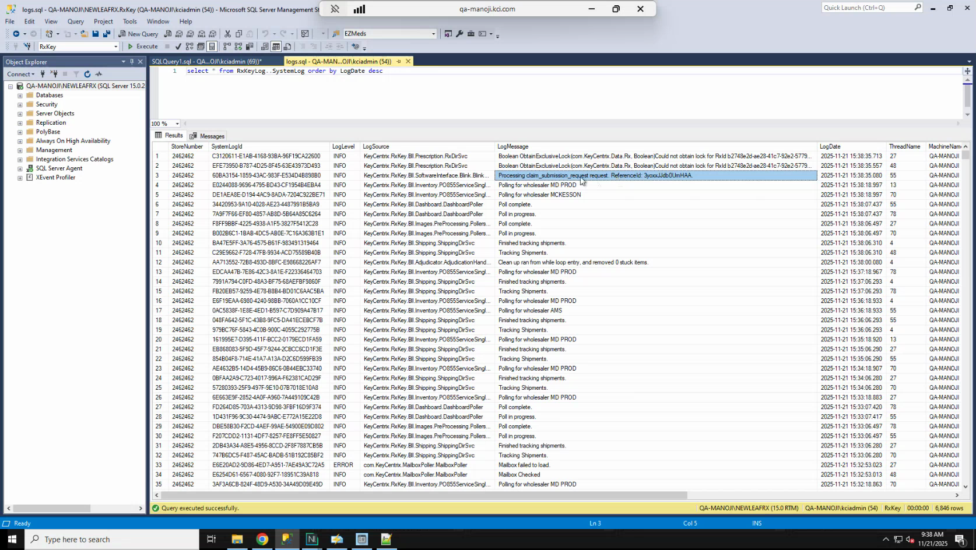
Candidate screenshot at 00:34:30.000

22. Confirm the claim is processing in System Logs
Action: In New Leaf System Logs, refresh and look for entries named Processing Claims Submission Request. These entries confirm that the claim adjudication is running.
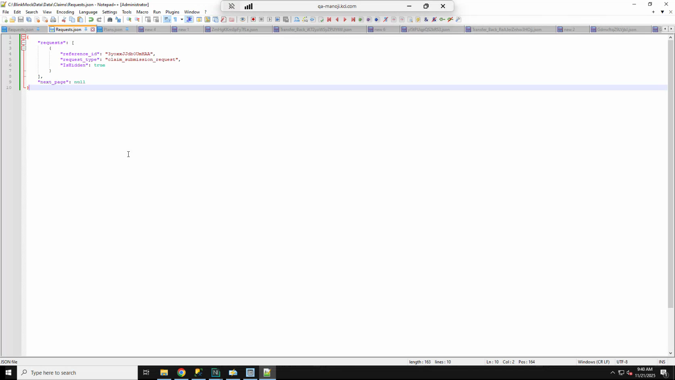
Candidate screenshot at 00:36:00.000

23. Stop the claim request immediately after the first poll
Action: As soon as you see the Processing Claims Submission Request log entry, return to the claims requests.json file, set isHidden back to true, and save the file.
Important: If the claim request continues to run, it will process the claim multiple times. This will cause the prescription to become read-only in New Leaf. If this happens, the prescription will become editable again after the Dispense request is processed. To avoid this, stop the claim request as quickly as possible after the first run. If you need more time, increase the polling interval to 20–30 seconds before activating the claim.
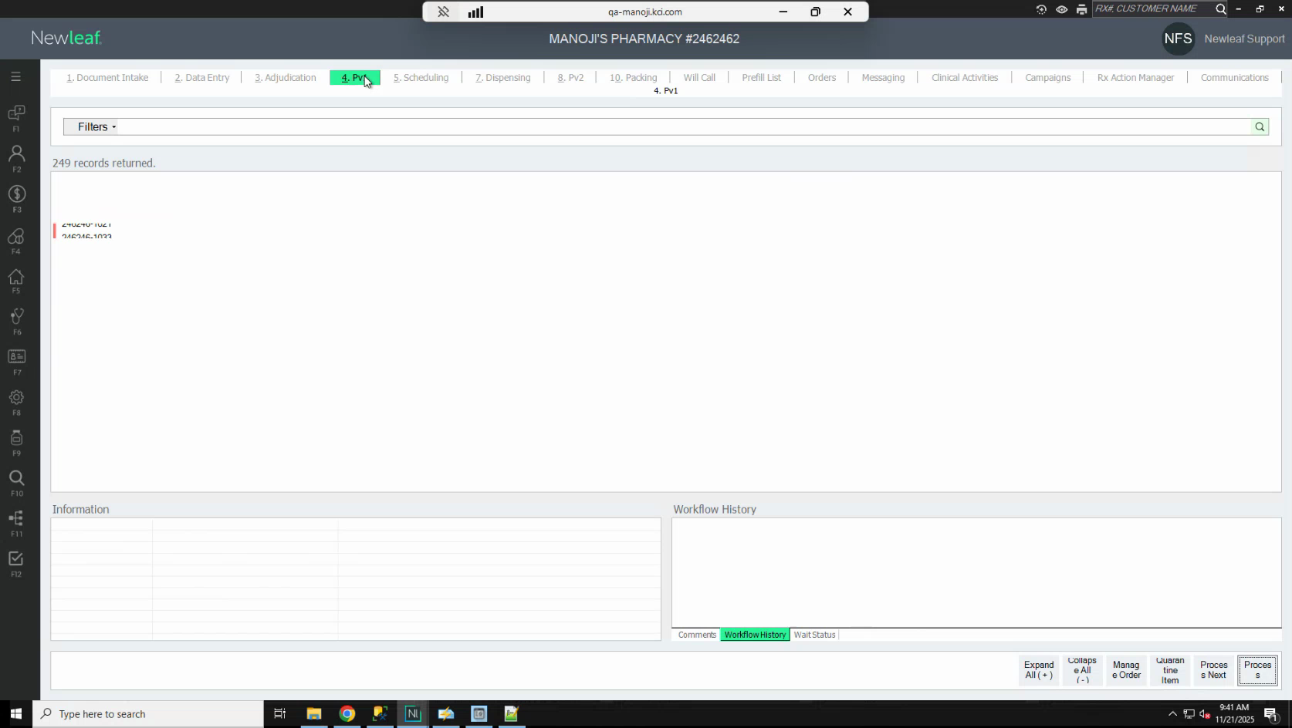
Candidate screenshot at 00:37:30.000

24. Verify the order has moved to PV1
Action: After the claim processes successfully, refresh your workflow view. The order should now appear in the PV1 stage. Open the order to confirm that the three plan tiers (primary, secondary, and tertiary) have been adjudicated.
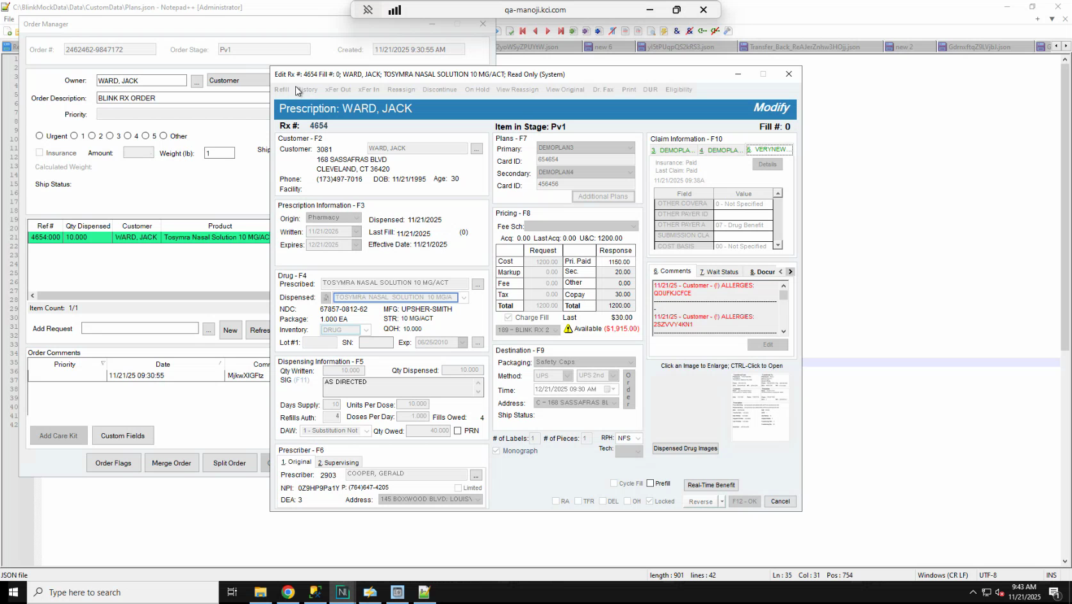
Candidate screenshot at 00:39:00.000

Run the Dispense Request

25. Understand what the dispense request does
Action: After the claim is complete, Blink sends a Dispense request to New Leaf. This request signals that the order is ready to be processed through the dispensing workflow. When the Dispense request is received, New Leaf records a Dispense Request Received timestamp on the order and removes the PDR order flag.
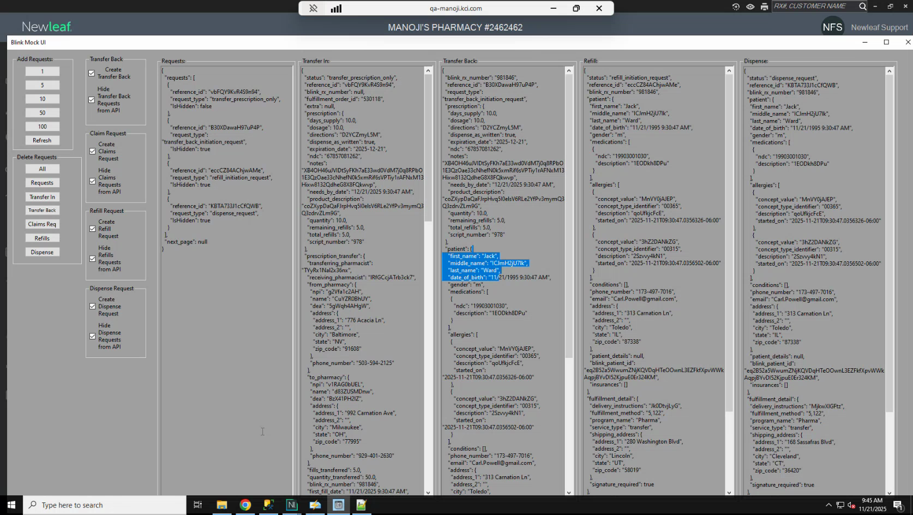
Candidate screenshot at 00:41:00.000

26. Understand the PDR order flag
Action: When a Blink order reaches PV1 after the claim request, the PDR flag is automatically enabled on the order. This flag indicates that the order is waiting for the Dispense request from Blink. While the PDR flag is active, you cannot process the order further in the New Leaf workflow. Once the Dispense request is received and the flag is removed, you can continue processing the order normally.
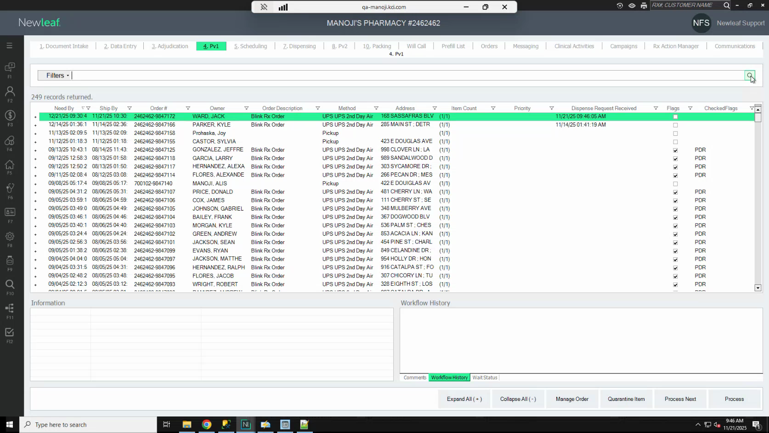
Candidate screenshot at 00:42:30.000

27. Activate the dispense request
Action: Open the requests.json file in the Blink Mock Data folder. Locate the Dispense Request entry and set isHidden to false. Save the file.
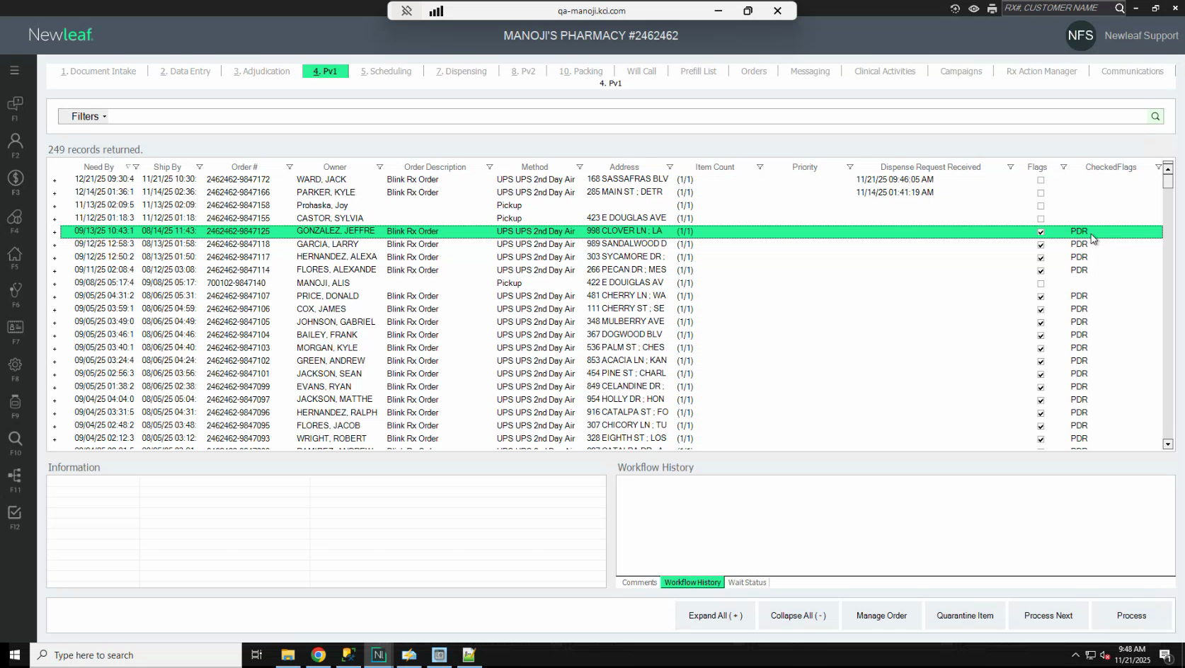
Candidate screenshot at 00:44:00.000

28. Confirm the dispense request in System Logs and stop the request
Action: In New Leaf System Logs, refresh and look for entries named Processing Dispense Request followed by the order reference ID. As soon as you see this entry, return to the requests.json file, set the Dispense Request entry's isHidden back to true, and save the file.
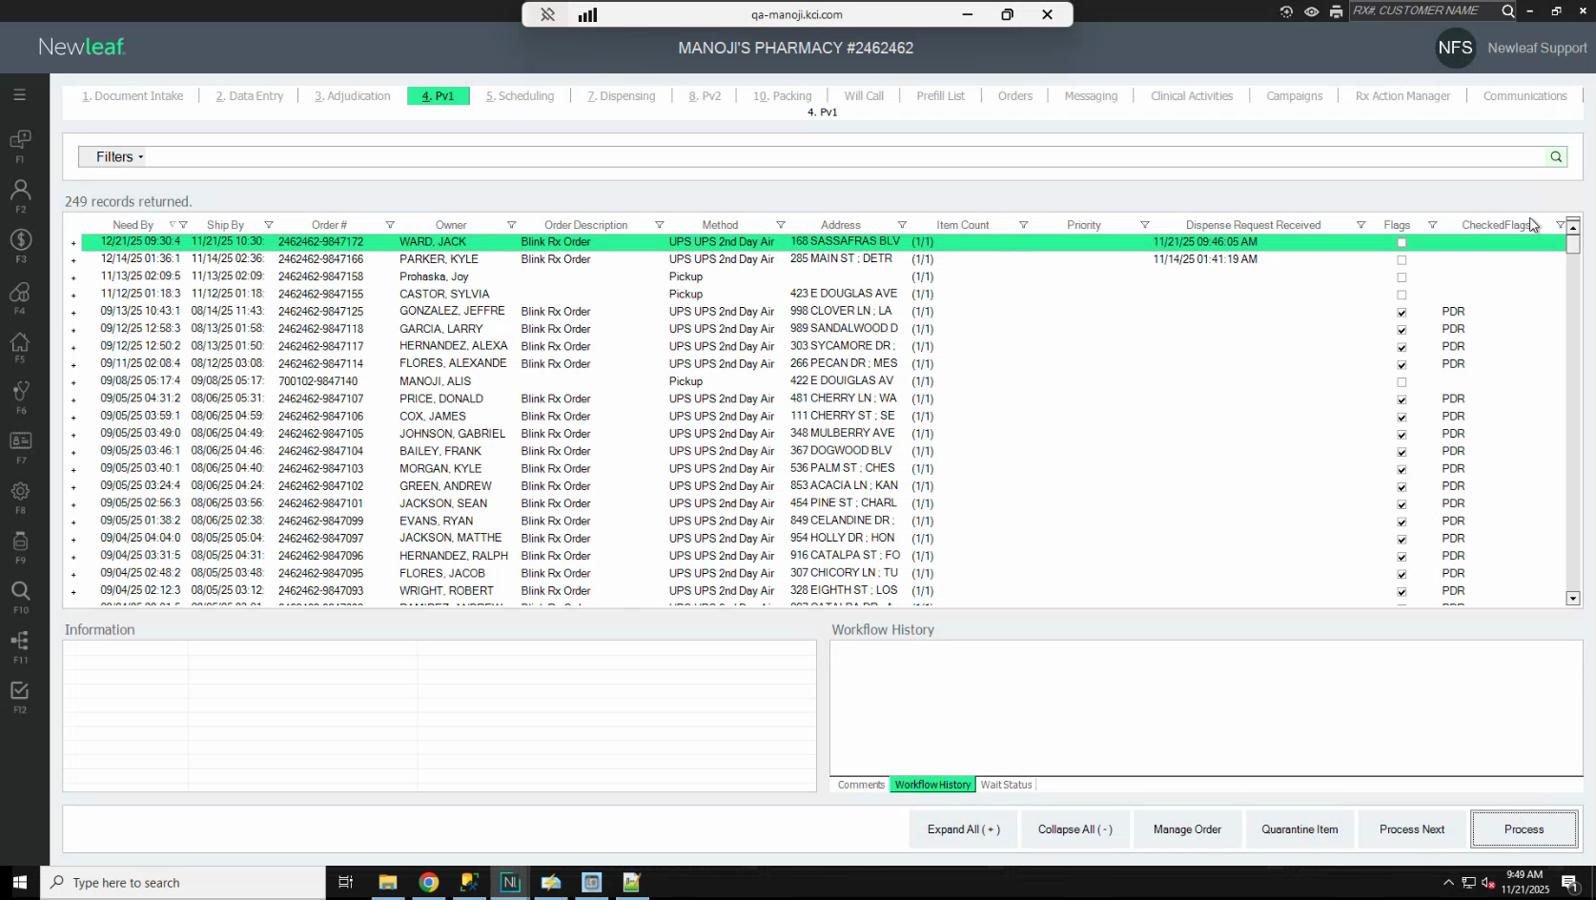
Candidate screenshot at 00:45:30.000

29. Verify the order is ready to process
Action: Refresh the PV1 order view. Confirm that:
- The Dispense Request Received timestamp is now recorded on the order.
- The PDR flag is no longer checked on the order.
Once the PDR flag is removed, you can process the order through the remaining New Leaf workflow steps as you would for any standard order. Note that Blink orders skip the scheduling stage and proceed directly to dispensing.
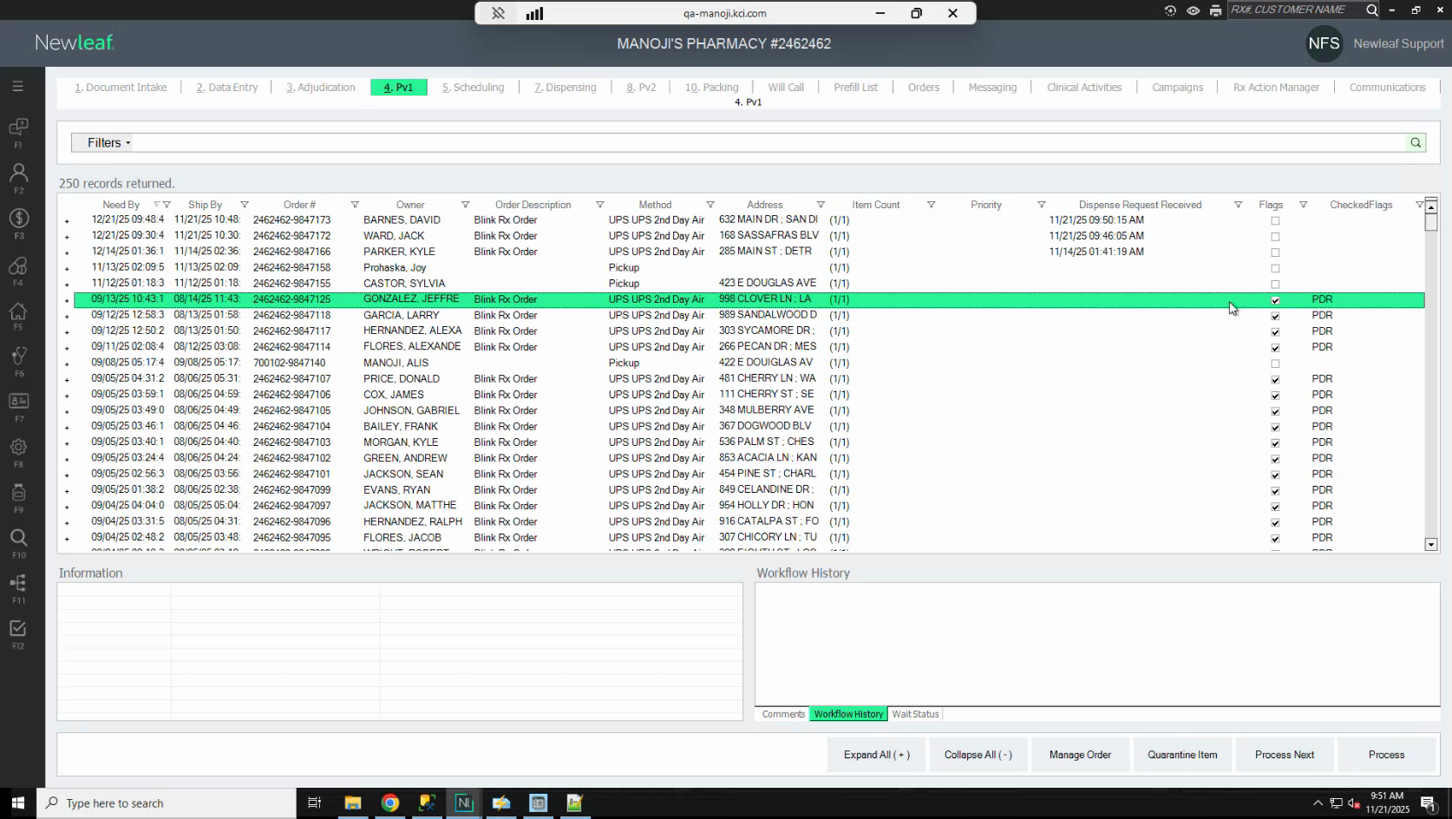
Candidate screenshot at 00:47:30.000

Run a Transfer Back Request

30. Understand the three Transfer Back scenarios
Action: A Transfer Back request returns an order to Blink. You can initiate a Transfer Back at three points in the workflow, and the result differs depending on when it is sent:
1. After Transfer In (order in Data Entry): The order moves to Completed status, is marked as Transferred, and is removed from Data Entry.
2. After the Claim request (PDR flag still active): The claim is reversed and the order returns to the adjudication stage.
3. After the Dispense request (PDR flag removed): The order is marked as Transferred and Completed.
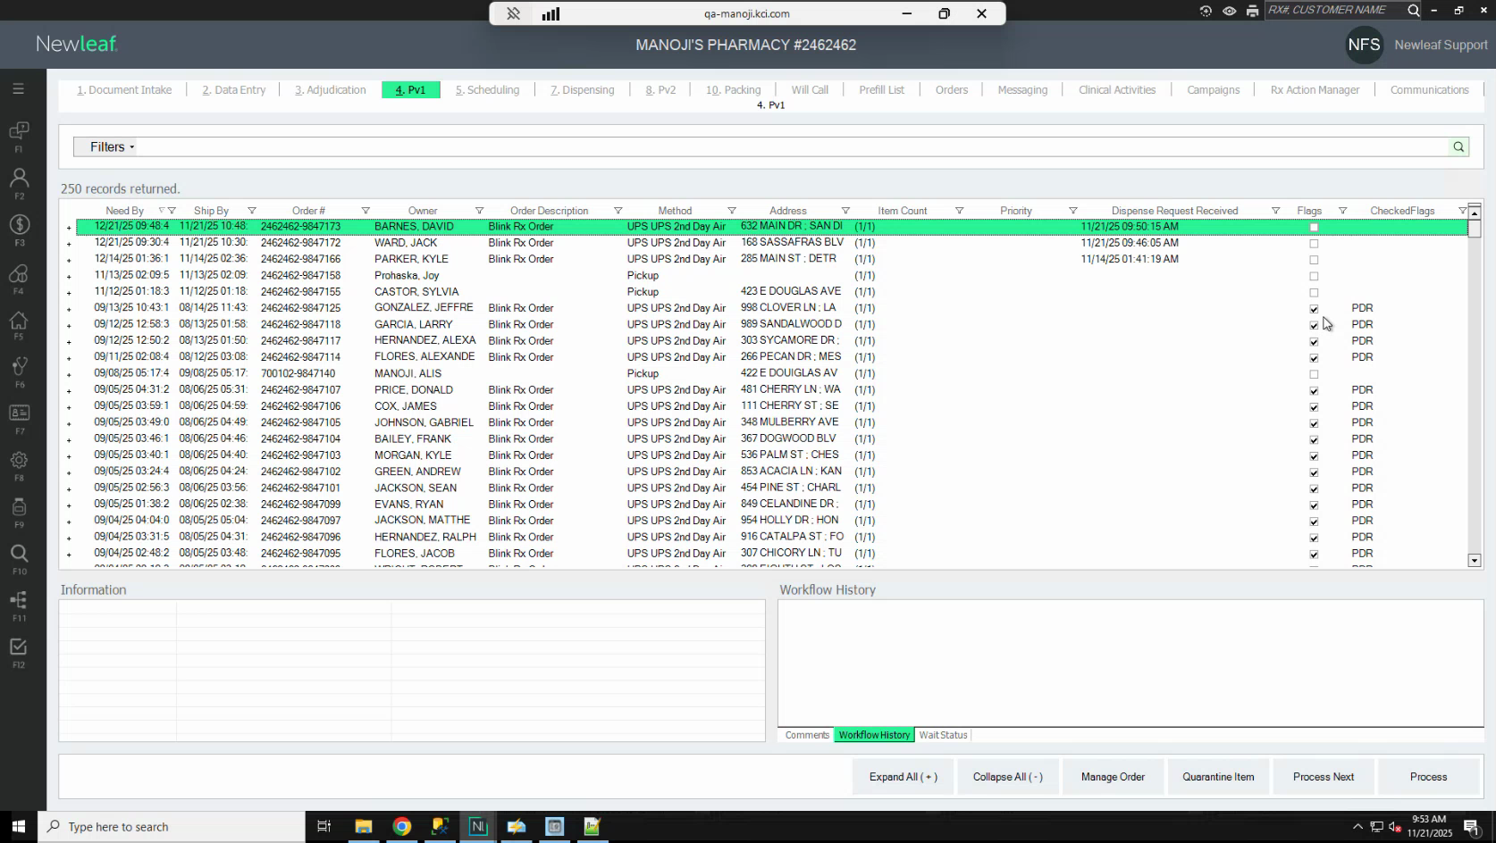
Candidate screenshot at 00:49:00.000

31. Activate the Transfer Back Initiation request
Action: Open the requests.json file in the Blink Mock Data folder. Locate the Transfer Back Initiation Request entry and set isHidden to false. Save the file.
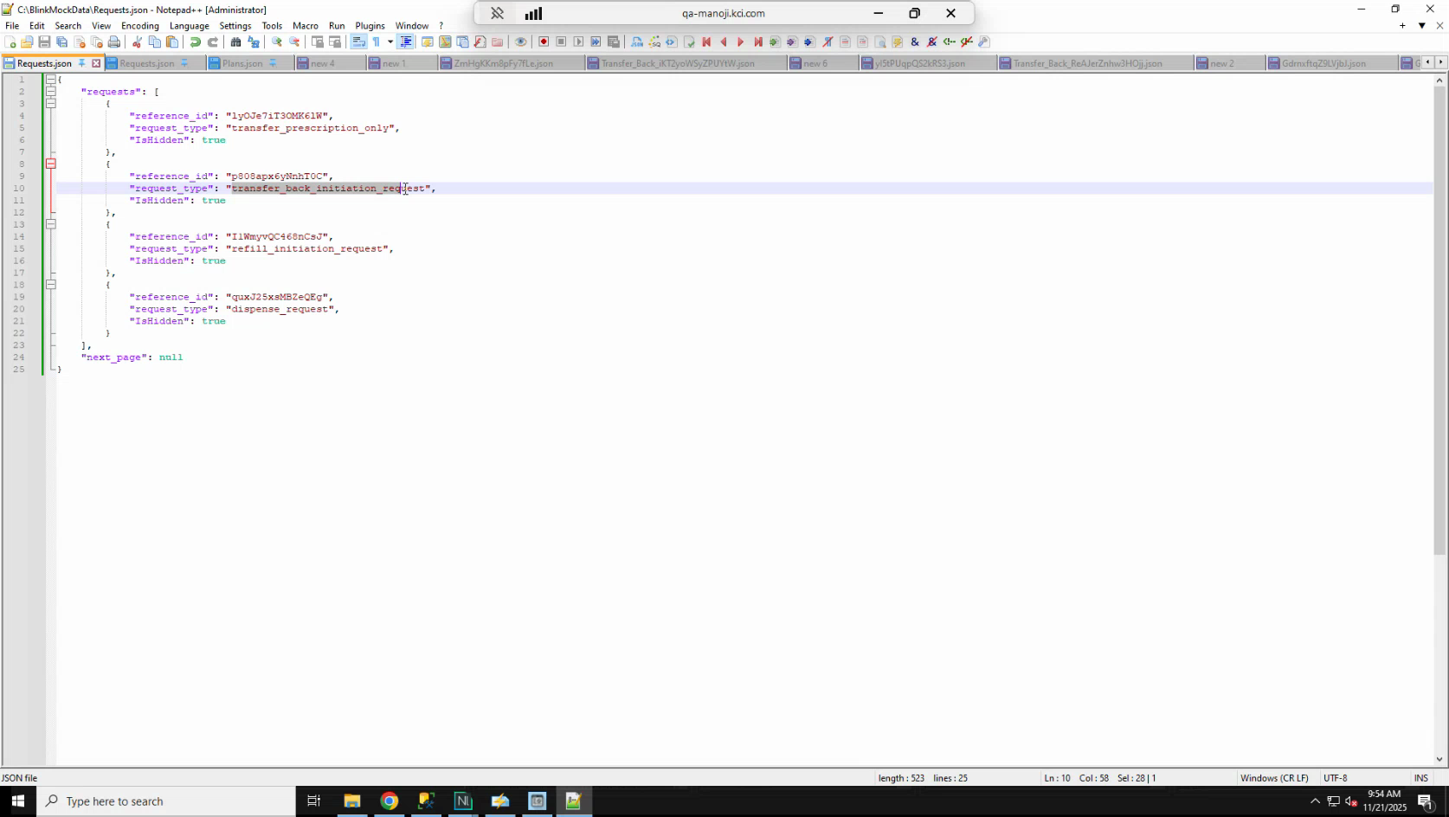
Candidate screenshot at 00:50:30.000

32. Confirm the Transfer Back in System Logs and stop the request
Action: In New Leaf System Logs, refresh and look for entries named Processing Transfer Back Initiation Request. As soon as you see this entry, return to the requests.json file, set the Transfer Back Initiation Request entry's isHidden back to true, and save the file.
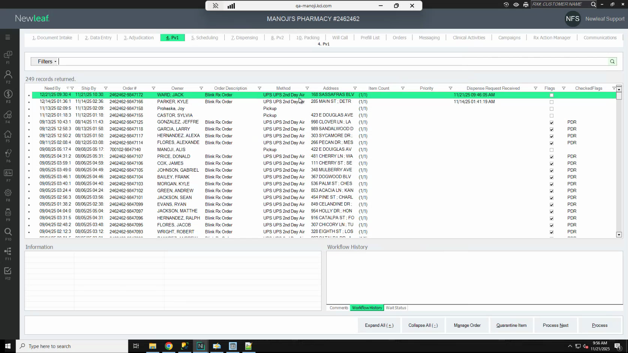
Candidate screenshot at 00:52:00.000

33. Verify the order status after Transfer Back
Action: In New Leaf, search for the order using F10 or by the order number. Confirm that the order status shows Transferred and Completed.
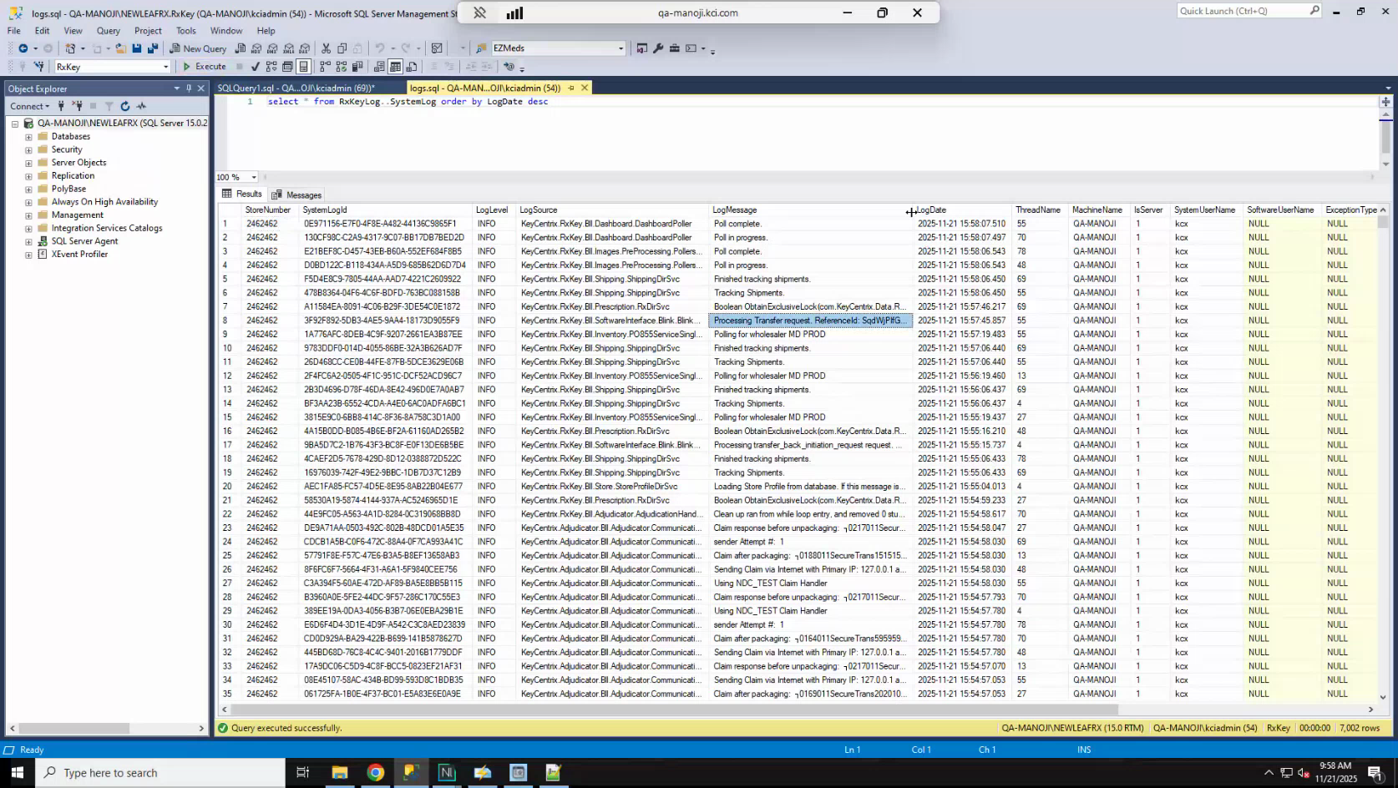
Candidate screenshot at 00:54:00.000

Monitor Blink Activity Using Logs and the Blink Request Table

34. Use System Logs to monitor polling activity
Action: In New Leaf, open System Logs and sort by log date descending. Use the following log source names to identify Blink activity:
- Blink Fulfillment Processor — Confirms that the polling processor is running.
- Processing Claims Submission Request — Confirms that a claim request is active.
- Processing Dispense Request — Confirms that a dispense request is active.
- Processing Transfer Back Initiation Request — Confirms that a transfer back request is active.
Each log entry includes a reference ID that corresponds to the order being processed.
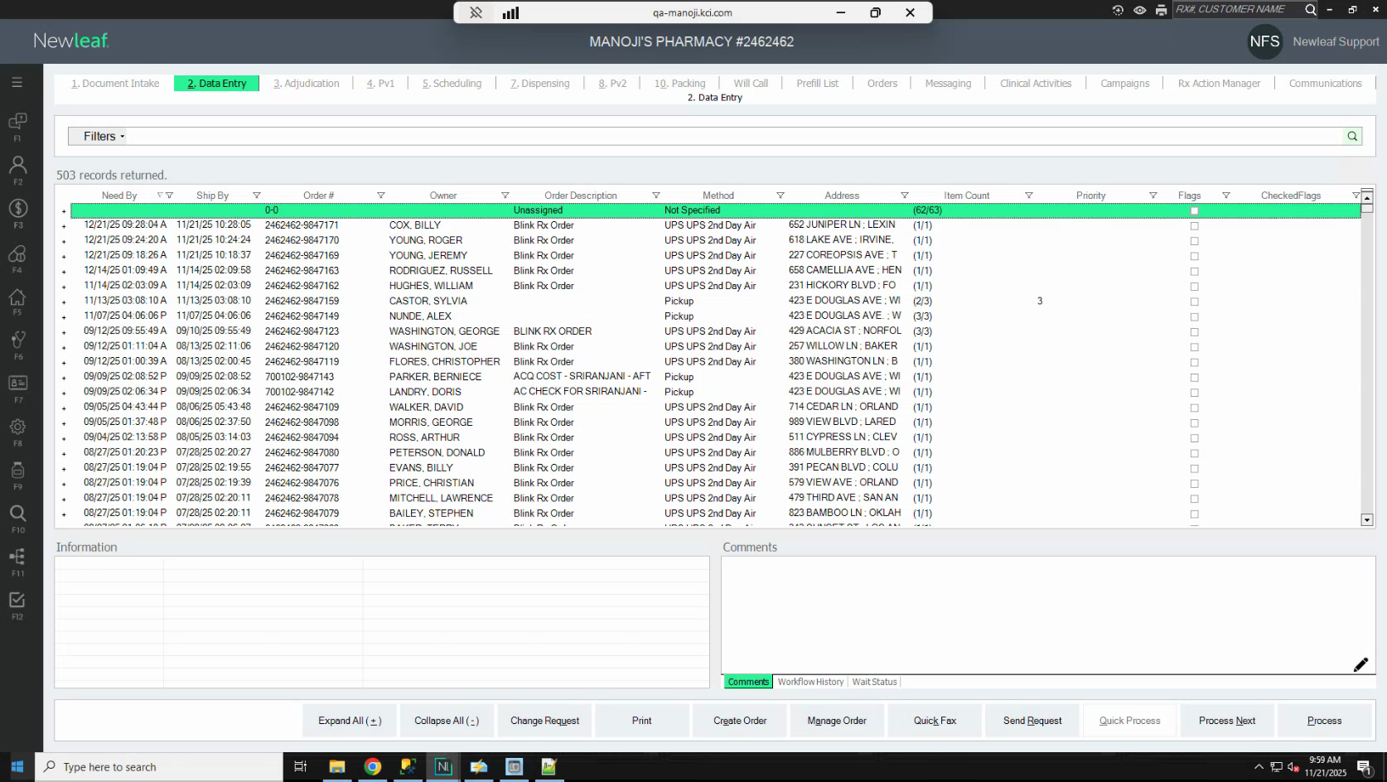
Candidate screenshot at 00:55:30.000

35. Use the Blink Request table to review request status
Action: New Leaf maintains a dedicated Blink Request table that shows the current status of all Blink requests. You can use this table to confirm which request types are running and to review the request history for a specific order.
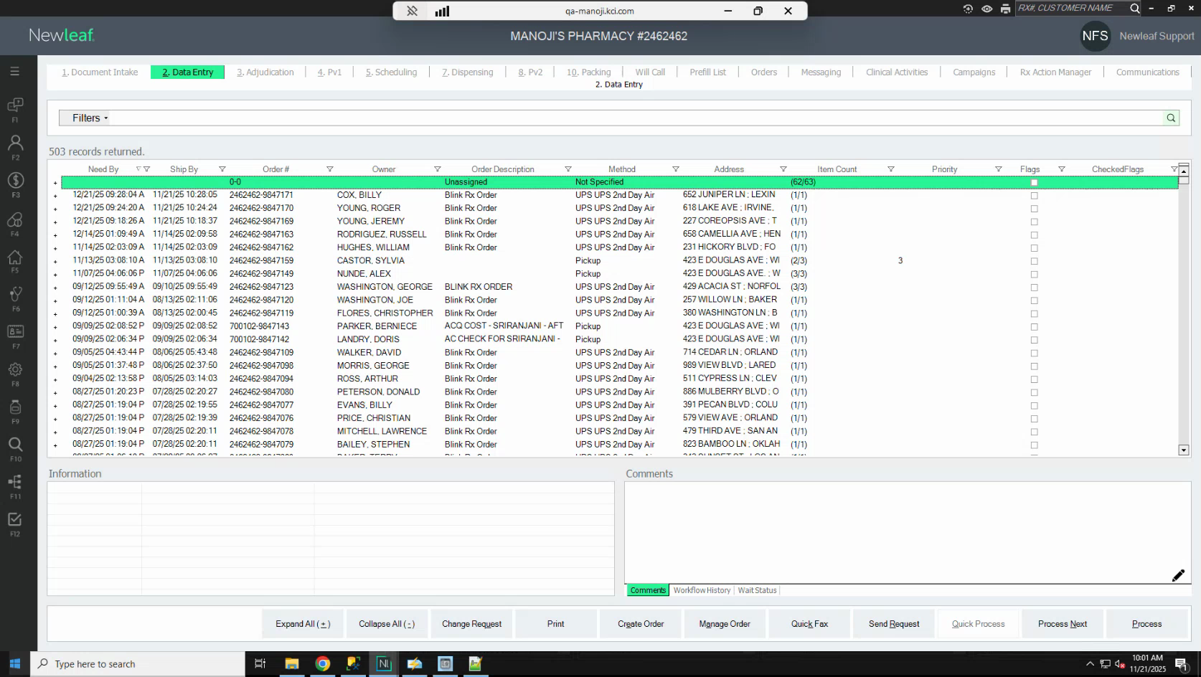
Candidate screenshot at 00:57:00.000

Expected Results
- The user can complete the documented workflow and confirm the expected request or configuration outcome.

Troubleshooting Notes
- If the workflow does not match the current application behavior, confirm the current process with the appropriate application owner.

Appendix: Source Recording Metadata

Document Control Metadata
Metadata Field | Document Value
Application | New Leaf / Blink RX Interface
Recording Duration | Not specified
Recorded At | Not specified
Source Recording | Blink Rx Training Part 1 112125.mp4
Input File | /Users/djames/Documents/AppDev/KCXDocumentor/artifacts/generated/blink-rx-training-part-1-112125-4eba47fa6aa0/guide_draft.anthropic.json

